Name: Abdul Rehman, ID : 149019176

Solve the following questions. Copy the commands below each question and also the screen shot of the result below the command. Upload the document on Blackboard.

1. Create table CITIES **from table LOCATIONS,** but only for location numbers less than 2000 (do NOT create this table from scratch).

🡪 You will have exactly 10 rows here.

When you describe CITIES, the output is shown below:

SQL> DESC cities

Name Null? Type

----------------------------------------- -------- -----------------

LOCATION_ID NUMBER(4)

STREET_ADDRESS VARCHAR2(40)

POSTAL_CODE VARCHAR2(12)

CITY NOT NULL VARCHAR2(30)

STATE_PROVINCE VARCHAR2(25)

COUNTRY_ID CHAR(2)

Ans -1)

**Statement:**

create table CITIES AS

(select * from locations

where location_id < 2000);

**Result:**

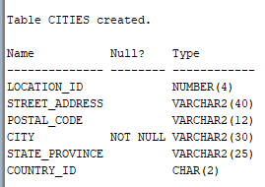

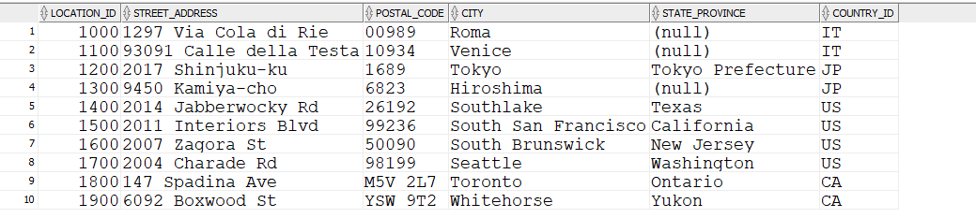

Rows: 10

2. Create table TOWNS **from table LOCATIONS,** but only for location numbers less than 1500 (do NOT create this table from scratch). This table will have same structure as table CITIES.

🡪 You will have exactly 5 rows here.

Ans-2)

Statement:

create table towns as

(select * from locations

where location_id < 1500);

Result:

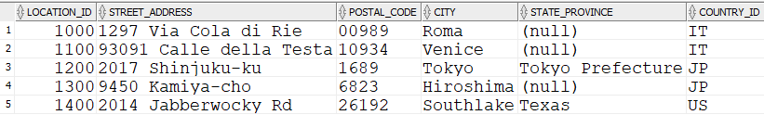

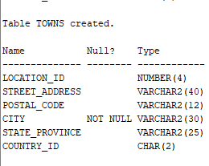

3. Create simple view called CAN_CITY_VU, based on table CITIES so that will contain only columns Street_Address, Postal_Code, City and State_Province for locations only in CANADA. Then display all data from this view.

**Statements:**

create or replace view CAN_CITY_VU as

select Street_Address, Postal_Code, City, State_Province

from cities

where COUNTRY_ID = 'CA';

**Output:**

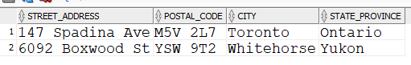

4. Modify your simple view so that will have following aliases instead of original column names: Str_Adr, P_Code, City and Prov and also will include cities from ITALY as well. Then display all data from this view.

**Statement:**

create or replace view CAN_CITY_VU as

select Street_Address "Str_Adr", Postal_Code "P_code", City, State_Province "Prov"

from cities

where COUNTRY_ID = 'CA' OR country_id = 'IT';

**Output:**

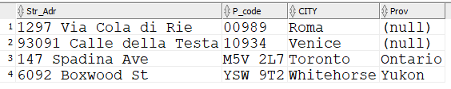

5. Create complex view called CITY_DNAME_VU, based on tables LOCATIONS and DEPARTMENTS, so that will contain only columns Department_Name, City and State_Province for locations in ITALY or CANADA. Include situations even when city does NOT have department established yet. Then display all data from this view.

**Statement:**

create view city_dname_vu as

select d.department_name, l.city, l.state_province

from locations l left join departments d

on (l.location_id = d.location_id)

where l.country_id = 'IT' OR l.country_id = 'CA';

**Output:**

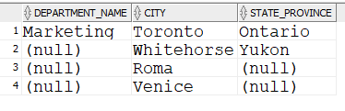

6. Modify your complex view so that will have following aliases instead of original column names: DName, City and Prov and also will include all cities outside United States

Include situations even when city does NOT have department established yet. Then display all data from this view.

**Statement:**

create or replace view city_dname_vu as

select d.department_name "DName", l.city "City", l.state_province "Prov"

from locations l left join departments d

on (l.location_id = d.location_id)

where l.country_id != 'US';

**Output:**

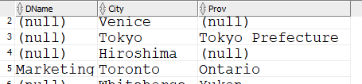

Rows:19

7. Check in the Data Dictionary what Views (their names and definitions) are created so far in your account. Then drop your CITY_DNAME_VU and check Data Dictionary again. What is different?

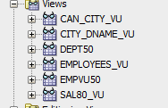

After dropping city_dname_vu

